The 56 year old participant had a health condition for a number of years and consequently had his PCV licence revoked by the DVLA. As a result this led to him losing his job as a bus driver which he had held for over 15 years.

Mr Saghir first attended step by step in September 2014, referred by the jobcentre following sanction. Mr Saghir explained his circumstance and how he had spent a large amount of time with medical appointments trying to get his medical status addressed in respect of reapplying for his PCV licence, but JCP did not view these activities seeking work. Mr Saghir also had very limited IT skills. Mr Saghir was very frustrated with the system as his medical issues which had resulted in the loss of his PCV licence had been resolved and was reapplying for the licence which was taking a lot of time. Additionally, he was unable to complete the IT aspect of applying for jobs and left him at a disadvantage and at risk of further sanctions. Mr Saghir had a family with a young child and was the main income earner.

Initially, it was important the his CV was updated, understood what his jobseeker claimant commitment requirements were, his step by step advisor explained his obligations, updated his CV, carried out job searches and applied for jobs with him. Mr Saghir then decided to attend additional step by step session in his area, and completed a basic IT course at Paddock Community Trust. Meanwhile, Mr Saghir continued to pursue the reapplication for his PCV licence which was taking time.

The step by step advisor monitored progress with his licence and in January asked Mr Saghir if he would like assistance with the reapplication, Mr Saghir, was very despondent with the lack of progress with the reapplication for his licence so welcomed the assistance. Mr Saghir felt strongly that the delay was preventing him from gaining employment and been unnecessarily dependent on benefits.

The step by step advisor helped Mr Saghir to complete documentation from the DVLA then rang the DVLA weekly to monitor the progress and ensure all requirements were been met. Unfortunately, despite completing the DVLA requirements he was advised to reapply for the licence. At this point his step by step advisor recommend he lodged a complaint in April 2015 as the reapplication did not appear to be been dealt with efficiently, an email of complaint was sent by Mr Saghir with help from his advisor. He received no response, so he was advised to seek assistance from his local MP and he was assisted in sending an email requiring the help of his local MP Mr Sheerman early May 2015.

On 25th May Mr Saghir received his PCV licence through the post, and went to his last step by step session on Friday 29th of May informing his advisor that he had secured employment and would commence employment with K Line Buses as a bus driver on Monday 1st June.

Mr Saghir thanked the advisor, Paddock Community Trust and Mr Sheerman MP in gaining his licence and employment, in an email to Mr Sheerman stated,

“I am writing to you to send you my most sincere thanks and appreciation for the assistance you have given me in respect of me regaining my PCV driving licence.
I have now received my driving licence back with full PCV which is valid for 5 years. This has made a dramatic difference to my life, as I am commencing employment on Monday 1st June as a bus driver with K Line Buses.

I would also like you to be aware of the support and assistance I have received from Paddock Community Trust Charity in Huddersfield. The advisor has supported me fully in making job applications, fulfilling my jobseeker requirements and, moreover, completing forms, and ringing the DVLA at sessions to progress the reapplication of my licence, without the assistance I would not have gained my licence and employment”

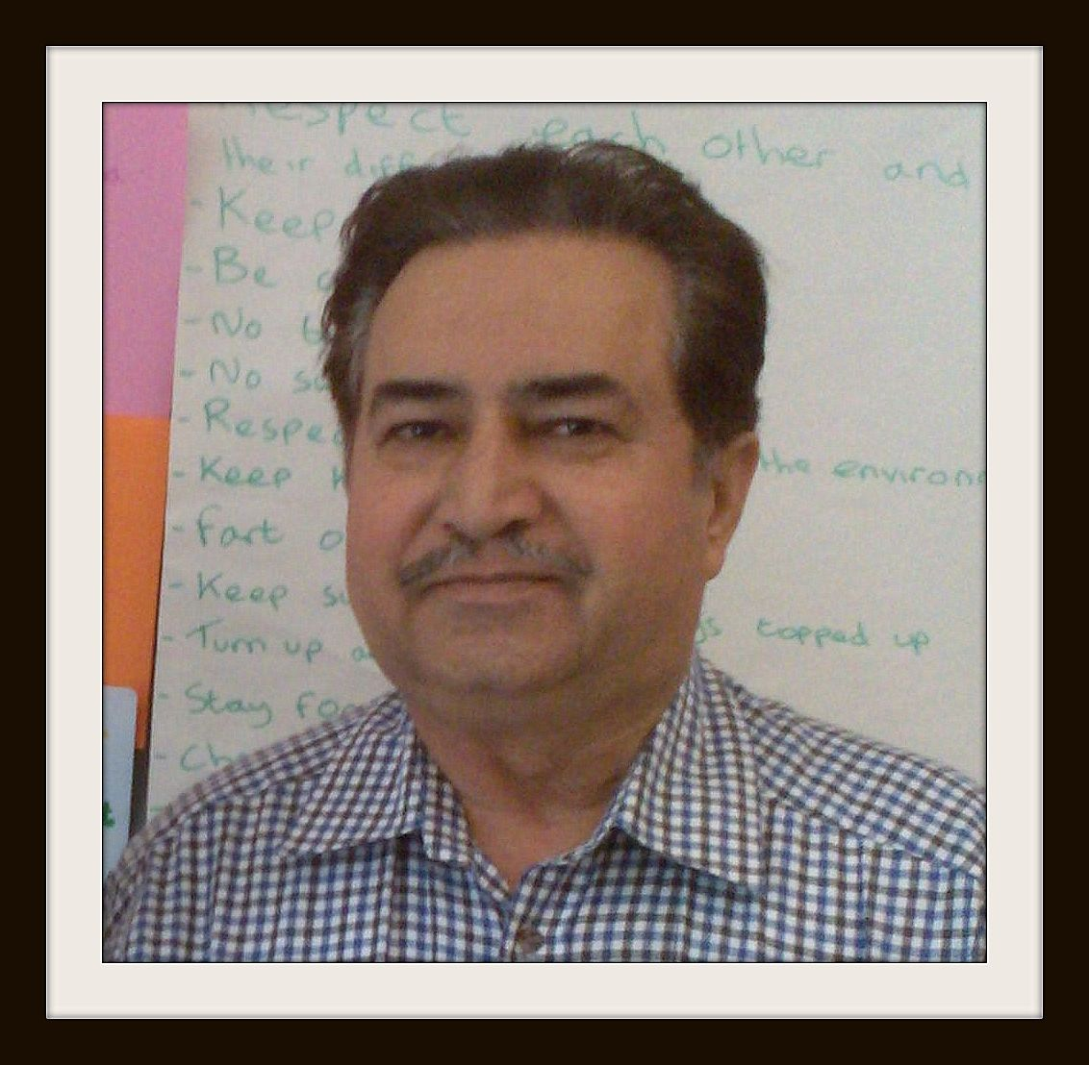

Mr Saghir at his last Step by Step session Fartown, 29/5/2015

